Solutions of mid-term examination

**Some comments:**

* Give the numerical results as decimal values, to permit me to avoid to calculate it myself when I give a score.
* Demonstrate your results with the place you have in the examination papers. Not all the steps are needed but enough place to understand what you have done, specially in case of mistakes.
* Next time, don’t forget your calculator without memory ...

Exercise 1.

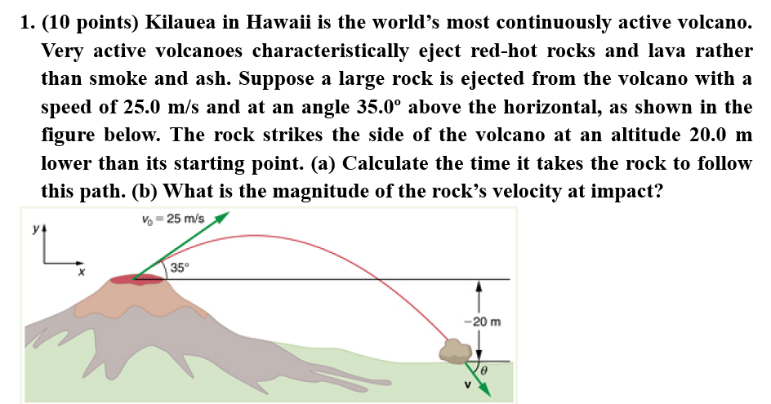

**Solution for a)**

While the **rock** is in the air, it rises and then falls to a final position 20.0 m lower than its starting altitude. We can find the time for this by using

y = y0 + v0yt -0.5gt2

If we take the initial position y0 to be zero, then the final position is y = −20.0 m. Now the initial vertical velocity is the vertical component of the initial velocity, found from v0y = v0 sin θ0 = ( 25.0 m/s )( sin 35.0º ) = 14.3 m/s . Substituting known values yields

−20.0 m = (14.3 m/s)t –(4.90 m/s2)t2

Rearranging terms gives a quadratic equation in t, of the form at2 + bt + c = 0 , where the constants are a = 4.90 , b = – 14.3 , and c = – 20.0. Its solutions are given by the quadratic formula, which yields two solutions: t = 3.96 and t = – 1.03 . The time is t = 3.96 s or – 1.03 s . The negative value of time implies an event before the start of motion, and so we discard it. Thus, t = 3.96 s.

**Solution for b)**

From the information now in hand, we can find the final horizontal and vertical velocities vx and vy and combine them to find the total velocity v and the angle θ0 it makes with the horizontal. Of course, vx is constant so we can solve for it at any horizontal location. In this case, we chose the starting point since we know both the initial velocity and initial angle. Therefore:

vx = v0 cos θ0 = (25.0 m/s)(cos 35º) = 20.5 m/s.

The final vertical velocity is given by the following equation:

vy = v0y − gt,

where v0y was found in part (a) to be 14.3 m/s . Thus,

vy = 14.3 m/s − (9.80 m/s2)(3.96 s)

so that

vy = −24.5 m/s.

To find the magnitude of the final velocity v we combine its perpendicular components, which gives

v = 31.9 m/s.

**Exercise 2.**

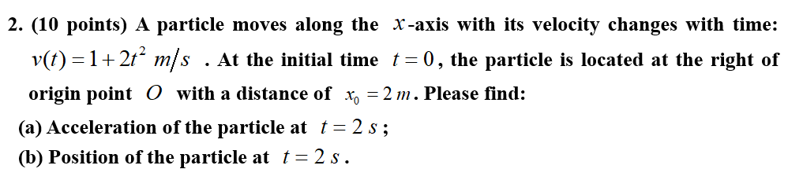

**Solution:**

1. $a_{x}\left(t\right)=\frac{dv(t)}{dt}=4t/s^{2}$; $a_{x}\left(t=2s\right)=8m/s^{2}$;
2. $v_{x}\left(t\right)=\frac{dx(t)}{dt}$ → $\int_{x_{0}}^{x}{dx\left(t\right)=\int_{0}^{t}{v_{x}\left(t\right)dt=\int_{0}^{t}{(1+2t^{2})dt}}}$

$${\left[x\right]}_{x_{0}}^{x}={\left[t+\frac{2}{3}t^{3}\right]}_{0}^{t}$$

$$x-x_{0}=t+\frac{2}{3}t^{3}$$

$$x=x_{0}+t+\frac{2}{3}t^{3}$$

$x_{0}=2m$; So, $x\left(t=2s\right)=\frac{28}{3}m=8.33 m$

**Exercise 3.**

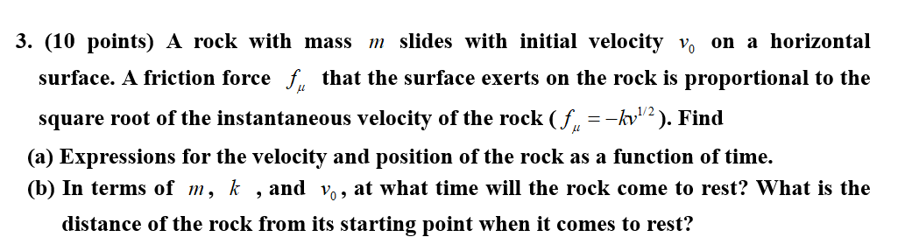

Solution.

$F_{R}=ma=m\frac{dv}{dt}=-kv^{1/2}$*→ $\int_{v_{0}}^{v}{\frac{1}{v^{\frac{1}{2}}}dv}=\int{-\frac{k}{m}dt}$*

${\left[2v^{1/2}\right]}_{v_{0}}^{v}={\left[-\frac{k}{m}t\right]}_{t_{0}}^{t}$

$2\left(\sqrt{v}-\sqrt{v_{0}}\right)=-\frac{k}{m}\left(t-t_{0}\right)$

$2\left(\sqrt{v}-\sqrt{v_{0}}\right)=-\frac{k}{m}t$*→ $v=v_{0}-\frac{k}{m}\sqrt{v_{0}}t+\frac{k^{2}}{4m^{2}}t^{2}$*

$v=\frac{dx}{dt}$*→ $x=x_{0}+v_{0}t-\frac{k}{2m}\sqrt{v_{0}}t^{2}+\frac{k^{2}}{12m^{2}}t^{3}$*

(b) $v=0$ *→ $t=\frac{2m\sqrt{v_{0}}}{k}$ $x\left(t=\frac{2m\sqrt{v_{0}}}{k}\right)-x_{0}=\frac{2mv_{0}^{3/2}}{3k}$*

**Exercise 4.**

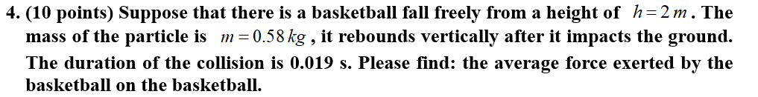

**Solution.**

(mistake in the exercise: it was the average force exerted by the basketball on the ground or the average force exerted by the ground on the basketball)

The basketball falls freely from a height of , the speed at the time when it begin to impact the ground is v such as:

**,**

**Thus: **

After the impact, it rebounds vertically without any loss of energy, then the final speed is , while the direction of the velocity is opposite, thus we have the average force exerted by the basketball on the basketball:



**Thus: **

**Comment:** some students confused the force exerted by the ground on the basketball and the average net force exerted on the basketball which is the sum of two forces:

* the force exerted by the ground during the collision,
* the gravitational force exerted on the basketball (described by the vector weight $\vec{w}=m\vec{g}$) .

The average net force exerted on the basketball during the collision is the change of momentum of the basketball during the collision.

However, because of the short time of the collision, the gravitational force has negligible effect on the basketball momentum during the collision, thus the average net force exerted on the basketball during the collision **is approximately** the average force exerted by the ground on the basketball.

If you have a doubt about this, you can compare the change of momentum due the gravitational force and due to the impact between the basketball and the ground.

**Exercise 5.**

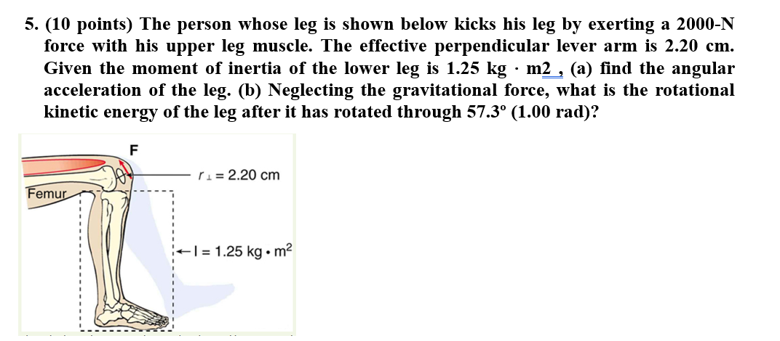

**Solution for a)**

From the rotational analog to Newton’s second law, the net torque exerted is $\vec{τ}=I\vec{α}$ where $α$ is the angular acceleration and $I$ is the moment of inertia about the axis of rotation. The angular acceleration α is:

$$α=τ/I$$

Because the force and the perpendicular lever arm are given and the leg is vertical so that its weight does not create a torque, the net torque is thus

net τ = r⊥ F = (0.0220 m)(2000 N) = 44.0 N ⋅ m.

Substituting this value for the torque and the given value for the moment of inertia into the expression for α gives

α = 44.0 N ⋅ m / 1.25 kg ⋅ m2 = 35.2 rad/s2.

**Solution of b)**

For a constant angular acceleration,

$$ω_{z}=\frac{dθ}{dt}=ω_{0,z}+α_{z}t$$

$$t=\frac{ω_{z}-ω_{0,z}}{α_{z}}$$

The angular displacement is, for a constant angular acceleration:

$$θ=θ_{0}+ω_{0,z}t+\frac{1}{2}α_{z}t^{2}$$

At $t=0, θ_{0}=0, ω_{0}=0,$ and we obtain ω2 = 2αθ

The kinetic energy of rotation is

$$E_{k,rot}=\frac{1}{2}Iω^{2}=Iαθ=44.0 J$$

**Exercise 6.**

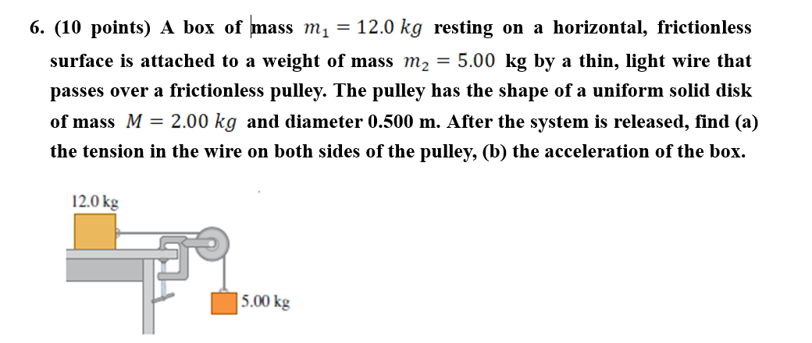

Solution.

About the mass $m_{1}$, the weight and the normal force cancel to each other, the tension force exerted on the mass is then the net force exerted on it, we obtain by applying the Newton’s 2nd law:

$T_{1}=m_{1}a$*Eq. (1)*

About the mass $m_{2}$ by applying the Newton’s second law.

$m_{2}g- T_{2}=m_{2}a$*Eq. (2)*

Take care that we cannot consider that $T_{1}=T_{2}$ because the pulley has a certain angular acceleration, it was not explicitly said on the exercise that the pulley has rotational motion but the exercise give all the information to calculate the moment of inertia of the pulley about its axis of rotation so it should have been a big hint about to take care of the rotational motion of the pulley.

Using the rotational analogy of the Newton’s second law, the net torque exerted on the pulley is $\vec{τ}=I\vec{α}$.

We obtain:

$\left(T_{2}-T_{1}\right)R=I∙α$*Eq. (3)*

where the moment of inertia of the pulley (with the shape of a disk of radius R and mass M) about its axis of rotational motion is:

$I=\frac{1}{2}MR^{2}$*;*

$a=R∙α$*Eq. (4)*

*Insert (1) and (2) into (3), and considering (4), we obtain:*

$$a=\frac{m_{2}}{\frac{1}{2}M+m_{1}+m_{2}}g=\frac{25}{9}=2.78 m/s^{2}$$

$T_{1}=m_{1}a=\frac{100}{3}=33.3 N$*; $T_{2}=m_{2}\left(g-a\right)=\frac{325}{9}=36.1 N$*

**Exercise 7**

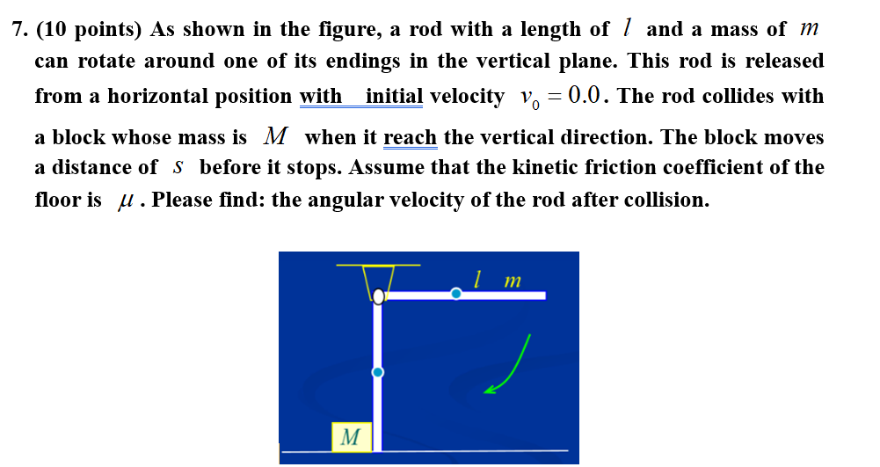

Solution.

We consider the conservation of mechanical energy (no friction for is considered when the rod is rotating, the only friction considered is when the block moves on the table), thus:

$\frac{1}{2}mgl=\frac{1}{2}I{ω_{0}}^{2}$;

where $\frac{1}{2}mgl$ is the change of potential energy of rod (we have to consider here the change of height of the center of mass of the rod ) between the time where the rod is released and just before the collision, $I=\frac{1}{3}ml^{2}$ is the moment of inertia and $ω_{0}$ is the angular velocity of the rod just before the collision.

We have seen that a body in motion has translational and rotational kinetic energy corresponding to the translational and rotational motion. However, the rotational kinetic energy is the sum of kinetic energy of the particles in the rod, and in the present situation we consider the rod as a body which kinetic energy corresponding only to its rotational kinetic energy $\frac{1}{2}I{ω_{0}}^{2}$.

With the conservation of mechanical energy of the rod, we obtain:

$$ω_{0}=\sqrt{\frac{mgl}{I}}=\sqrt{\frac{mgl}{\frac{1}{3}ml^{2}}}=\sqrt{\frac{3g}{l}}$$

During the collision, there is conservation of angular momentum of the system block+rod. The block is seen as a particle, thus : $\frac{1}{3}ml^{2}ω_{0}=Mvl+\frac{1}{3}ml^{2}ω_{ }$

where $ω$ is the angular velocity of the block after the collision. Considering the friction exerted on the block during its motion, the change of its mechanical energy is the work done by the friction

$$μMgs=\frac{1}{2}Mv^{2}$$

$$v=\sqrt{2μgs}$$

Thus : $ω_{ }=\frac{m\sqrt{3gl}-3M\sqrt{2μgs}}{ml}$

**Exercise 8**

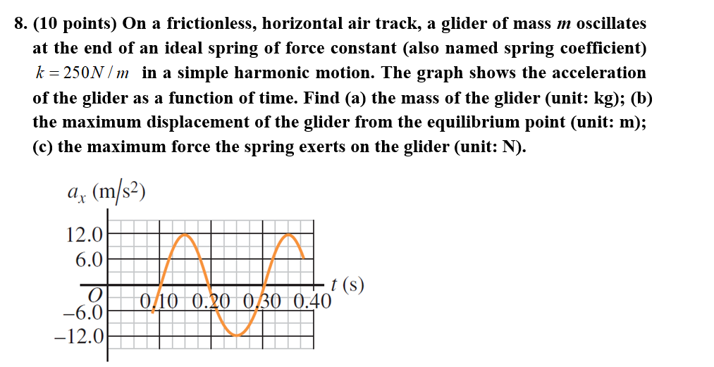

**Solution**

(a)The acceleration oscillates at the same angular velocity than $x(t)$, i.e. $ω=\sqrt{k/m}$

$$T=\frac{2π}{ω}=2π\sqrt{m/k}$$

We obtain:

$$m=k{\left(\frac{T}{2π}\right)}^{2}$$

$$m=k{\left(\frac{T}{2π}\right)}^{2}$$

$$m=\left(250 N.m^{-1}\right){\left(\frac{0.20 s}{2π}\right)}^{2}=0.253 kg$$

(b)

$$a_{x}\left(t\right)=-\frac{k}{m}x(t)=-\frac{k}{m}Acos\left(ωt+ϕ\right)$$

$$a_{x,max}=-\frac{k}{m}x_{max}=-\frac{k}{m}A$$

The maximum acceleration is:

$$a_{max}=\frac{k}{m}A$$

$$A=x_{max}=\frac{ma_{max}}{k}=\frac{\left(0.253 kg\right)\left(12.0 m.s^{-2}\right)}{250 N.m^{-1}}=0.0121 m$$

(c) $F_{max}=kA=ma_{max}=\left(0.253 kg\right)\left(12.0 m.s^{-2}\right)=3.04 N$

**Exercise 9.**

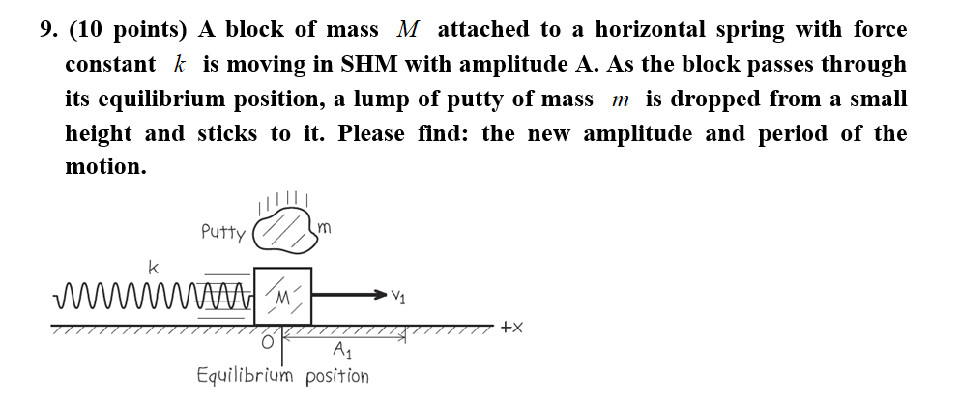

Solution

Before the collision the total mechanical energy of the block and spring is . As the block is at the equilibrium position, the energy is purely kinetic . Thus we can find the speed of the block at this point:



During the collision the -component of momentum of the block-putty system is conserved. Just before the collision, this component is the sum of  (for the block) and zero (for the putty). Just after the collision, the block and putty move together with speed . From conservation of momentum, we have:



We assume that the collision lasts a very short time, so that the block and putty are still at the equilibrium position just after the collision. The energy is still purely kinetic:



Since , we can obtain the amplitude after the collision as:



Thus, we have:



The period of the motion is:



Exercise 10.

**10.(10 points) As shown in the figure is the graph of displacement as a function of time ($x=f(t)$). Please find: the expression of displacement as a function of time in the form .**

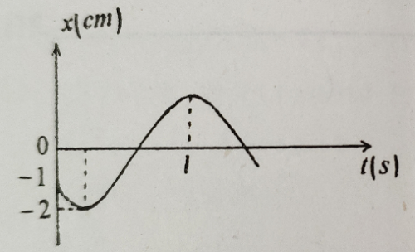

Solution

**A=2.0 cm; t=0 s,** ，

and the particle is “moving” toward -2 cm,

thus we have: 

From  to  and then to , the time it takes is , thus



We have:

